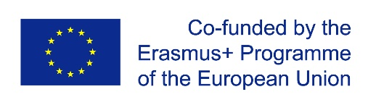  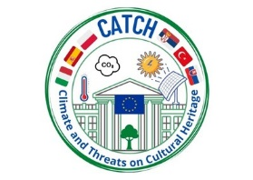

**Climate and Threats on Cultural Heritage**

**CATCH**

**Erasmus+ KA 229 Project**

**LESSON PLAN**

|  |
| --- |
| **Name of the lesson** Designing various things out of waste materials |
| **Grade** 13 - 14 years old |
| **Subject** English language, Art, ICT |
| **Time** 4 Lesson Hour |

|  |
| --- |
| **Target Behaviours -** To collect the necessary materials as plastic bottles and cups, cans, paper  and plastic bags, newspaper   * To design plans for recycling bottles and caps, cans, paper and plastic bags * To draw the outlines of the pictures they want to use with felt pens * To think recycling in terms of eﬀective use of resources. |
| **Keywords** Plastic bottles and caps, cans, paper bags, Recycling, Reuse, Reduce,  Rethinking |
| **Methods** Lecture, Group Work, Answer the evaluation questions |
| **Requirements**  As many plastic bottles, caps, cans, paper as possible, Colour Printer,  Hot Glue Gun, Silicone candle, Scissors, Ruler (50cm), Pencil, Craft knife,  Crayons, Stick glue |
| **Security** The teacher should warn the students about using hot glue gun and craft  knife. Hot glue gun can burn their fingers and craft knife can cut them. So,  students should use these gadgets carefully. Also teacher can help the pupils  when they use them. |
| **Warm up** Bring in plastic bottles, caps, empty cans, paper bags, some newspaper.  Divide the class into five groups, 6 students in each group. Assign each  group a coulour: red, blue, green, purple and orange. Give each group a  drawing. Ask each group to decide what material they will need.  Explain your students that they have plastic bottles, caps, empty cans, paper  bags, newspaper as materials for recycling, and tell them that they will work  in groups, they have to be careful while they use the gadgets, and to try  their best to make their designs as real as possible. |
| **Processing** Announce crafts time. Put all the necessary materials on the table.  Announce a competition between groups to see who can make the coolest  recycling picture. The winner group should satisfy the following criteria:   * The designe that raises students’s awareness of the importance of   recycling and provides solutions on how to save the planet.   * The designe also needs to include the recycle sign, project logo, group   members, name and surname and Erasmus beneficiary logos.   * All the groups will be the winners and their designed pictures will be put in the school hall. * The students can use computer to print logos and signs. Also they can research sample designs for recycling . |
| **Evaluation** The students fill the evaluation form below. |
| **Evaluation Form** |
| 1 - What did you learn in this activity? |
| 2 - What did you do well? Why? |
| 3 - What troubled you most? Why? |
| 4 - Where did you need help? |
| 5 - In which area should you improve yourself more? |
| 6 - What are your strengths and weaknesses? |